An agent-base model of a lake ecosystem

# Introduction

The initial motivation to create this model is to understand how critical transition happens in a shallow lake ecosystem under small perturbation. There have been some conceptual models, statistical models and system dynamic models illustrating various aspects and phases of transitions but still exists a gap between theories and experimenting theories of nonlinear transitions in a whole lake ecosystem. A set of real-world whole-ecosystem experiment was conducted by Carpenter et al. (2011) on early warning signals(EWS) of regime shifts, where top predators had been added in the experiment lake to destabilise the food web over 3 years. The work related theories of EWS indicators to fieldwork data by comparing population and biomass of planktivores, zooplankton and chlorophyll concentration between the manipulated and reference lake.

Although the approach of field experiment is vital to test hypotheses, the conduction could be demanding in expense and time. Having been widely used in ecology and sociology in recent decades, computer simulation can prepare researchers with possible lake ecosystem scenarios. From the aspect of model design, agent based models (ABMs) can be an economic and useful tool to see how the transitions emerge. ABMs are normally built on the key theoretical ecosystem interactions that designers postulate in driving the system toward the transition we concerned about. The results ABMs present can show system behaviour in a visible way so we can learn from the scenarios.

Here, the ABM aims to study transition scenarios on the background of dynamic equilibrium in a lake ecosystem with manipulated variables. The model uses the integrated development environment (IDE) of Netlogo (<http://ccl.northwestern.edu/netlogo/>). The goal of this model is that the system should stabilise itself dynamically under a certain magnitude of perturbation. All changes in populations should behave in a regular and predictable manner.

# Conceptual modelling

## the world structure

In the conceptual model, external environment is set as simple as possible to focus on biotic feedback loops that relate to system equilibrium or transition. Here we imagined a closed shallow water frequently and fully mixed enough that the water quality is homogenous all over the ‘world’. The environment is assumed as a shallow (0 - 6 m), warm, fixed nutrient pool where total nutrient is the sum of nutrient in organism and nutrient free in water. Nutrient is transferring between organisms and water in growth and death procedure. There is no sediment and the decomposition is simplified as a rapid enough process so nutrient can be released instantly into water when organisms die.

## Classification of species

The principle of classification mainly bases on organisms’ ecological niches and the ways of obtaining energy. Although there exists a huge diversity of habitats in shallow lake, e.g. planktonic, epiphytic, benthic and so on, here we only set limited groups of ‘agents’ that is related to key processes

Groups are divided by the ability to fix energy from sun and what diet it takes. For example, the vascular plants and algae that can photosynthesize are divided into (micro)phytoplankton, submerged macrophyte, floating plants. Similarly, consumers can be classified as planktivores, herbivores, omnivores, carnivores, etc. Herbivores include macro and micro groups, respectively representing herbivorous fish and zooplankton. Because of our research background, micro-phytoplankton has been divided into three major groups, which are diatom, green algae and cyanobacteria. Besides, there is no benthic and epiphytic habitat considered in this model for simplicity.

In summary, we have the list of roles in the conceptual model as diatom, green algae, cyanobacteria, submerged macrophyte, floating plants, zooplankton, planktivorous fish, herbivorous fish, omnivorous fish, piscivorous fish.

## traits of species

### Biomass-energy function

In this model, the relationship between biomass and energy is fixed by an exponential function:

In the reverse way, biomass can be calculated from energy as:

### Energy control

Energy works as a measurement of life state. Every ‘agent’ is born with a number falling in the range of initial energy related to its ‘breed’(species) . The first batch of organisms have a uniform value of energy from definition. Organisms obtain energy from their life strategy, either by photosynthesis or taking in diets. Biomass grows as soon as the energy increases in an organism. There is no energy limit for photosynthesis but for consumers. The energy of a full organism can limit the foraging behaviour.

Then, new agents that are hatched from an asexual reproduction process will share the energy of parents when enough energy has been accumulated by parents. By setting hatch number as the integer value of division of , the energy of new agents falls into the range close to .

## Space and size

In the setup of model, all organisms should distribute randomly in the window. Different breeds have own ‘breed’ size, e.g. diatom is much smaller than fish in body size. However, constrained by the need of simplicity, the magnitude difference between breeds has been scaled down to less than 10. Producers have an extra property of depth, that cannot be seen on screen but work as a variable of photosynthesis efficiency.

Habitat competition is taken into consideration between different breeds and inside breed. We assume that all organisms can sense fellows nearby and always tend to spread in nearby neighbourhood instead of squeezing together and producers could be shaded to decrease photosynthesis if being covered by other organisms in the same place but above.

## biotic interrelations

The relationships in the lake ecosystem follow the structure of food web and trophic levels (Figure 1). The assimilation efficiency, defined as the conversion rate of assimilated energy into new tissue, for consumers is set as 10%. There are three trophic levels including producers. Therefore, as a result, the sum of energy of primary producers should be around several hundred times the sum of primary consumers to support the whole ecosystem. As shown in the energy flow figure, metabolism takes away a portion of energy as life maintenance, leaving the other portion to grow biomass and reproduce when the energy is ready.

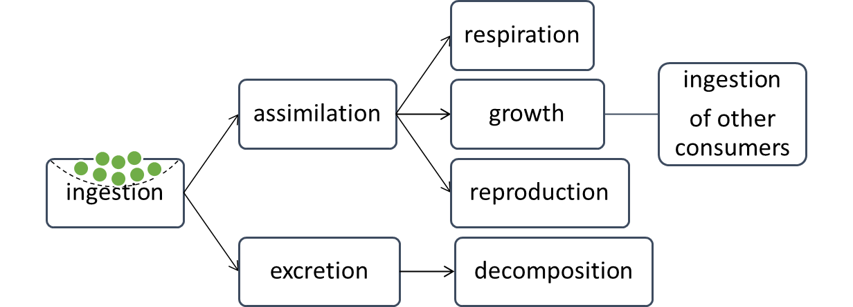

Figure Energy flowing in trophic levels

## Living strategies

The life strategies (on production, reproduction) are not going to adapt to the environment in this model, and hence, the ratios of production to biomass (P/B) are set as constant and varies between different breeds. Long-lived species (e.g. fish) should have low P/B while producers (e.g. phytoplankton) should take an opportunistic strategy and maintain high P/B, which exists in real ecosystem as K and r strategies (Barnes et al. 1980). Coexistence is not considered in this model. Only competence relationship works between species, but any form of mutualism. Last but not the least, in this model we assume there is always ‘seed’ of all breeds somewhere in the lake. When any breed extinct in any tick, one ‘seed’ will be awaken in the next run so that there will not be persistent extinction in this ecosystem.

### Phytoplankton life strategy

Phytoplankton, meaning diatom, cyanobacteria and green algae here, is the first tier of ‘agents’ to response to environment and get energy from light. The efficiency of phytoplankton production is constrained by light, nutrient and temperature varying on individual level.

### Consumer life strategy

Consumers mainly take in food in the place where they are. Considering time as a limit, each consumer has the same times of chance to clean food on their patch until getting full in energy. Unless food is still left on that patch, consumers should move on for more food around the present patch. When they move, organisms should always watch the surroundings, trying to land on a resource-rich patch and at the same time avoid predators.

Therefore, the food intake per step by consumers depends on how much food there are on the patch. The new energy assimilated in consumers’ body totally relies on the intake of prey per step as the assimilation rate is set as 10% for all. Since organisms are aware of and move towards resources, and they can stay longer if there are more food than they can finish in that chance, we can reasonably expect a free distribution of consumers where density of consumers matches the density of limiting resources. Besides food intake rate, we allow essential physiological variation between breeds, e.g. excursion radius.

## Environmental variables and processes

### temperature

Water temperature directly makes impact on the primary producers on GPP (Gross Primary Production) rate. We assume each breed has their most productive temperature range and production rate decreases outside the range.

Phytoplankton function with temperature is above.

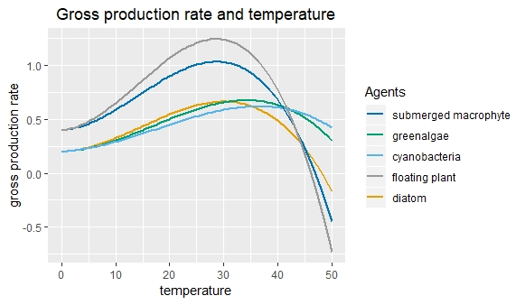

### water depth

Water depth constrained the light penetration and nutrient availability.

### Light attenuation

The light attenuation follows an exponential law and decrease from surface with depth *Z*.

is concentration of biomass of floating breeds.

### nutrient concentration

The total concentration of nutrient is composed of all nutrient in organisms and free in water. No specific nutrient element but just a generic concept of essential nutrient cycling is calculated here. The biogeochemical cycles of nitrogen and phosphorus are well studies in experiment but here we focus on the links between organisms and environment in the ecosystem instead of too many details.

Parameter stands for the nutrient concentration in the body of breed *i* and this parameter should be a constant for any breed. Parameter stands for biomass of breed *i* in a unit space.

Nutrient availability is reasonably assumed here to change exponentially with the depth *Z* where organism is situated.

### Phytoplankton

Phytoplankton’s growth is influenced by temperature, in-situ light attenuation (function of Z), in-situ nutrient level (function of Z) and community concentration and available space around. The higher phytoplankton density is, the lower mortality criterion is. Diatom, green algae and cyanobacteria compete with each other using different advantages in making use of available resources.

### Macrophytes

Macrophyte means submerged and floating macrophyte in this model. The increase of energy and biomass of macrophyte reacts similarly to the essential environmental conditions, i.e. temperature and nutrient in equation (4).

## Ecosystem behaviour

Imagining a closed equilibrium aquatic ecosystem without sediment, the recycling of nutrient should occur instantly and producers react sensitively. In this environment, we assume that populations first shoot to a high level a bit beyond the environment capacity and then after competition, return to a stable state. To take population under control after the overshoot, negative feedbacks are added in reproduction processes. For example, the energy boundary of macrophyte reproduction is related to nutrient level:

Typically the numbers and biomass of organisms decrease as one ascends the food chain. The assimilation efficiency of this process of assimilation varies in animals, ranging from 15-50% if the food is plant material, and from 60-90% if the food is animal material.

## Adaptation

The agents' properties could vary after every action of each agent as a response to environmental pressure and community strategy. For producers, individual photosynthesis rate, somatic reproductive rate and mortality criteria are multiplied by impact factors of environmental variables. For consumers, individual growth rate, somatic reproductive rate and mortality criteria are multiplied by impact factors too. The adaptive variables allow our system to stablise itself.

# Complement on Netlogo

## the world setting

The world (window of ABM) is set as a closed 2D space. The space wraps both horizontally and vertically so the ‘agent’ can move through the space boundary from one side to the other. By right clicking the window, users can change the world size of the model on ‘model setting’ interface.

Global parameters are ticks/days (time unit), water-temperature, water-depth, turbidity and nutrient concentration (total/free/in-phytoplankton/in-zooplankton/in-fish). Environmental variables, e.g. nutrient pool, temperature, water depth are set initially and changeable during process in the model.

## Interface of Netlogo

The system behaviours are controlled by switches and sliders on the interface.

Switches ‘setup’ ‘go’ ‘setup’ includes setting initial parameters, creating agents, and returning the initial state of global variables. The command ‘go’ includes life cycles of each agent in order of trophic levels, and fundamental refreshing processes in which variables and parameters are updated to keep agents adaptive to environment and community.

Sliders are set for researchers to adjust variables that we would like to test the response of system on. On the interface there is only temperature now but other parameters, e.g. whole nutrient concentration, can be adjusted too from codes.

The evolution of the lake ecosystem is on the window composed of pixels representing patches where organisms live on. In the window, ecosystem pattern change can be observed visually. Besides, a stack of monitors show population, biomass, energy and demography of breeds. To help analyse the system change temporarily and spatially, there are plots with horizontal axis of ticks show time series of individual and population index like available nutrient, initial breed properties and initial populations.

When we make the system move on, the visual pattern, statistics and time-series plots get refresh in the frequency we set. The default setting is once per tick and can be changed in window setting.

## algorithm of procedures

### Biomass and energy of agents

Table physiological parameters of agents in this lake ABM

|  |  |  |  |  |  |  |  |
| --- | --- | --- | --- | --- | --- | --- | --- |
|  | Agent name | Initial Biomass | Initial Energy | Survival energy | Biomass ^ BMR | Life span(ticks) | foraging repetition per tick |
| Phytoplankton | Green algae | 0.1 | 23.69 | 23 | 0.18 | 20 | N/A |
|  | diatom | 0.1 | 23.69 | 23 | 0.18 | 20 | N/A |
|  | cyanobacteria | 0.1 | 23.69 | 23 | 0.18 | 20 | N/A |
| Macrophytes | Submerged macrophyte | 0.4 | 190.04 | 100 | 0.50 | 200 | N/A |
|  | Floating plant | 0.4 | 190.04 | 100 | 0.50 | 200 | N/A |
| Zooplankton |  | 0.15 | 72.34 | 70 | 0.39 | 80 | 3 |
| Fish | Planktivores | 0.6 | 238.70 | 200 | 0.79 | 365 | pf |
|  | Omnivores | 0.6 | 238.70 | 200 | 0.79 | 365 | omf |
|  | Herbivores | 0.6 | 238.70 | 200 | 0.79 | 365 | hf |
|  | Piscivores | 0.8 | 273.22 | 200 | 0.96 | 700 | pisci |

For fish, foraging repetition are determined by both breed population and the hunting rate of that population.

If breed = *i*, foraging repetition () =, where is a constant parameter of breed property.

In reproduction procedure, the minimum energy of phytoplankton reproduction is

The minimum energy of macrophyte reproduction is

However, considering macrophyte has long life span and reproduction cycle, we set another criterion for each breed to reproduce like *age mod 31 = 30 for submerged macrophyte and age mod 16 = 15 for floating plants*.

# internal validation

For the conceptually complemented agent-based model, it is necessary to check the realistic aspect of the system to prepare the model of experiment and implication. In this model, since we aim to explore the process of ecosystem transition from equilibrium, some basic ecosystem behaviour and ecological laws should cohere well. Five aspects of reasonability are tested under this assumption, energy and biomass in photosynthesis, energy and biomass structure of trophic levels, population distribution, and population change respectively. We run experiment repetitively under the same condition where total nutrient concentration is 0.25 and water temperature is 24. Thus, the results should only vary with the random initial spatial distribution and stochastic processes during running.

## energy from photosynthesis to food web

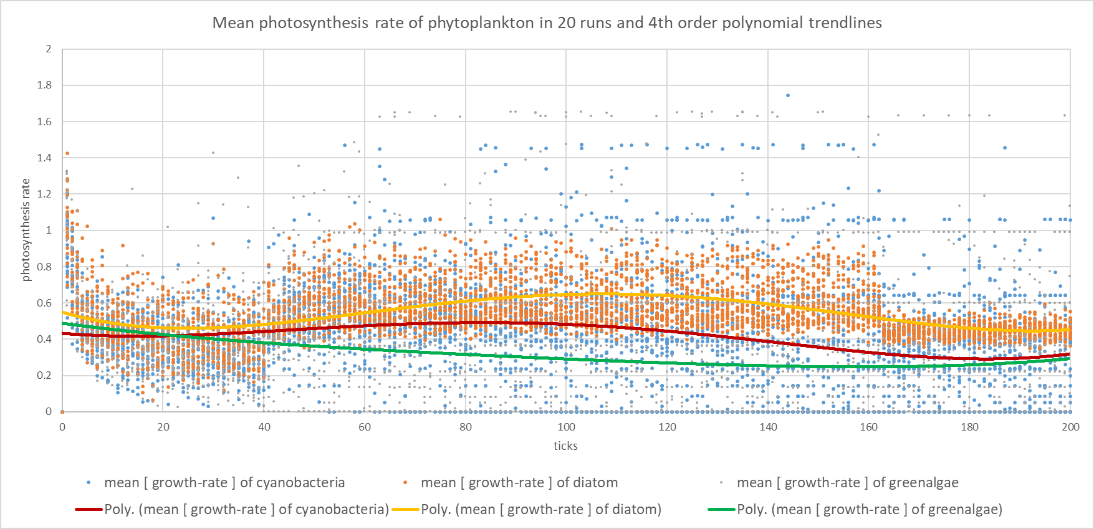

The variable “growth rate” means the photosynthesis rate the producer breed has in the last run so it can stand for gross energy increase. The trend of photosynthesis went high in the first 10 ticks when the breed is growing free beneath the environment capacity, and then dropped down due to the limit of free nutrient concentration as a result of overgrowing. After 60 ticks, the photosynthesis rate tends to stabilise, which means the nutrient in water is in a dynamic equilibrium too. This trend is logical and realistic in a lake ecosystem too.

## energy pyramid of the food web

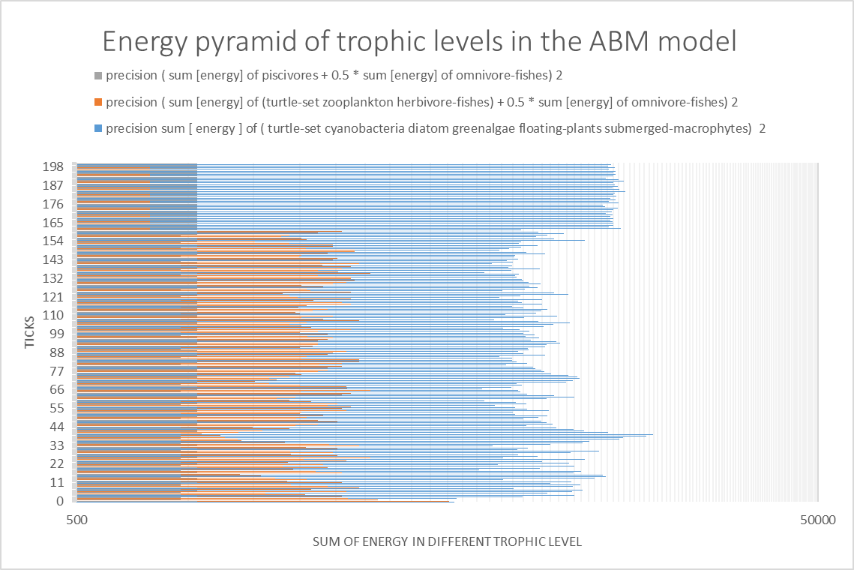

As shown in the above plot, the primary production is roughly 7 times the energy of the first-level consumers, and 15 times the energy of the second-level consumers along 200 ticks. The proportion is not quantitatively realistic but qualitatively fitting the ecosystem law of energy pyramid.

## population change

The time series of population change represent main information of the stability in the ecosystem. In population ecology, hypothetical examples of populations show S-shape curve due to limited environmental carrying capacity. Population numbers reach the equilibrium and maintain.

In the repetition runs of the model, populations seem to be in an equilibrium at least before 160 ticks.

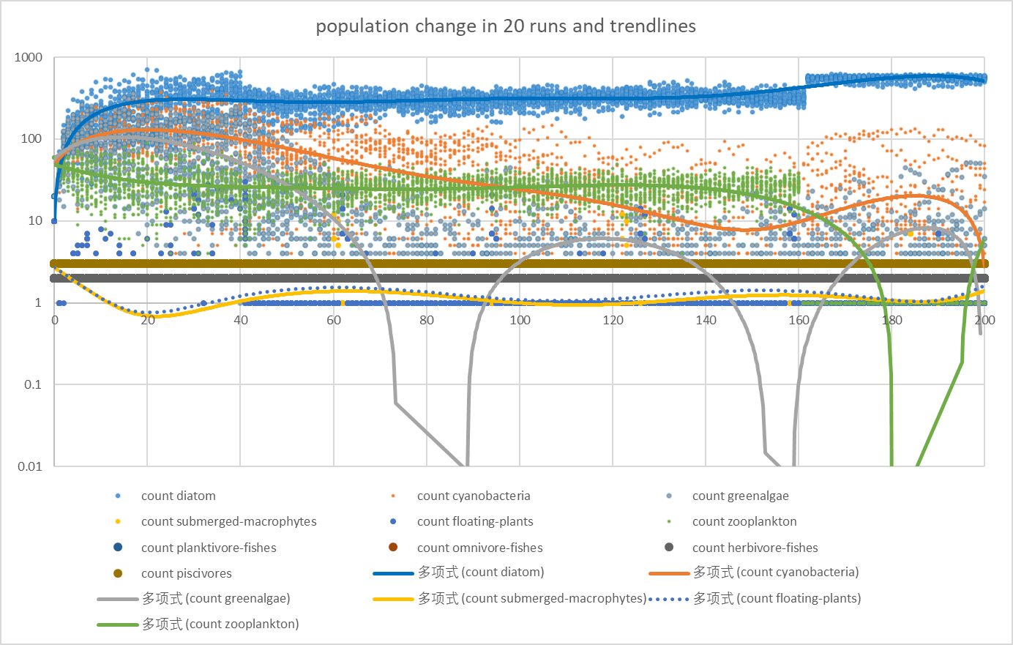

(sorry for the Chinese as it is automatic in my laptop, which means *polynomial fitting trendlines*)

# perturbation tests

Making small step changes in environment variables, effects of external forces can be observed in the simulation of perturbation tests. Here we run this ABM through a gradient of total nutrient concentration and temperature. To be specific, the total nutrient concentration varies from 0.15 to 0.65 with a discrepancy of 0.1 and the temperature changes from 12 to 36 with a discrepancy of 4.

## temperature

Take diatom as an example, we can see from the figure above that when temperatures are in range of 12 to 20℃(and the total nutrient concentration is set as default 0.25mg/L), diatom is growing steadily along the time and the population stays in equilibria. After the temperature reaches 24℃, diatom population is still following the same trend till the end of 200 ticks. Then dramatically, when the temperature is 28 or 32℃, diatom dies off at 60 and 140 ticks respectively. When the temperature is 36℃, diatom doesn’t grow due to the limit in the code.

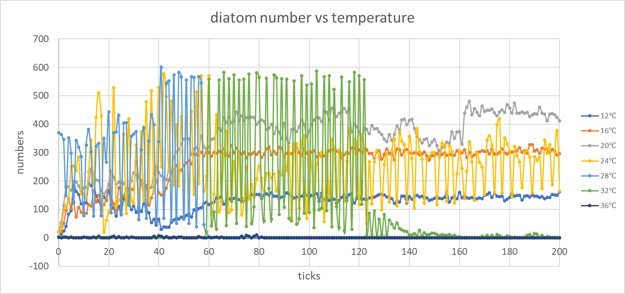

## total nutrient concentration

In the temperature of 24℃, tests go through a gradient of total nutrient concentration from 0.15 to 0.65. When the total nutrient concentration is 0.15, diatom number rises steadily and keeps in an equilibrium. At 0.25, the diatom population fluctuates a lot and stays in equilibrium as well. However, after the total nutrient rises beyond 0.35, all diatom numbers transit at around tick 160 and show typical regime shifts.

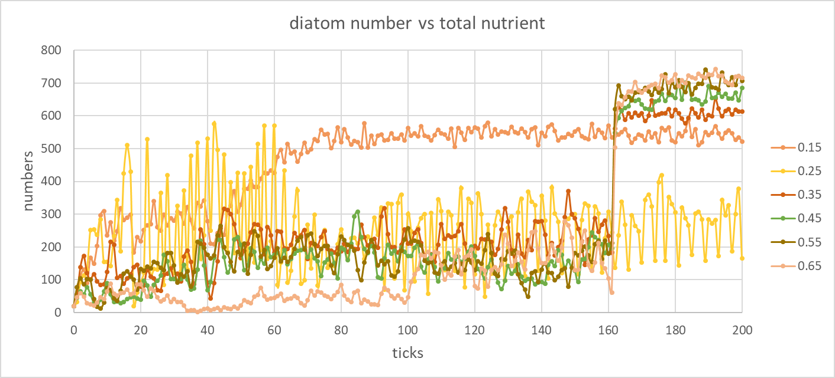

# Reference

Barnes RS, Barnes RSK, Mann KH. (1980) Fundamentals of Aquatic Ecosystems. Blackwell Scientific Publications.

Carpenter SR, Cole JJ, Pace ML, Batt R, Brock Wa, Cline T, Coloso J, Hodgson JR, Kitchell JF, Seekell Da, Smith L, Weidel B. (2011) Early Warnings of Regime Shifts: A Whole-Ecosystem Experiment. Science 332:1079-1082.